**Garmin Map Making Quickstart Guide**

If you want to make a detailed map with roads, lakes, etc., in addition to your trails, see my other guide [**here**](http://www.gpssledmaps.com/guide/index.php).

This will guide you through making a simple Garmin map from GPS tracklog files that can be transparent so it shows up over other Garmin maps.

**1)** Download and install this software:

[**GPSMapEdit**](http://www.geopainting.com/en/) - The program you'll use to actually create your map  
[**cGPSMapper**](http://www.cgpsmapper.com/en/download.htm) - The program that creates a file for use with your GPSr  
[**SendMap**](http://cgpsmapper.com/buy.htm) - For sending maps to your GPSr

Optional:  
[**Inno Setup**](http://www.jrsoftware.org/isdl.php) - For making Mapsource installable maps.

**2)** Download this file ( [**zipped**](http://www.gpssledmaps.com/guide/empty_map.zip), [**unzipped**](http://www.gpssledmaps.com/guide/empty_map.mp) ) and open it in GPSMapEdit.

**3)** Go to View > Levels > Level 0. A big blue square will appear. Click on it and delete it. It's just there because GPSMapEdit doesn't allow you to save a totally empty map.

**4)** Go to "File > Add..." and select your tracklog file. If it's in a format MapEdit can't understand, go [**here**](http://gpsvisualizer.com/gpsbabel/) to convert it to .gpx. Repeat this step for all files you wish to import.

**5)** Zoom into the area where your tracks are drawn so you can see what you're doing. Go to "Edit > Select > All Tracks" and then right click anywhere on a track. On the popup menu, do "Convert To > Polyline". Uncheck all boxes except for "Level 0" and click OK. Now delete the tracklog by doing "Edit > Select > All Tracks" and then "Edit > Delete" so that the tracklog is gone but your polyline is still there. The next screen asks you what type of object you want it to be. I chose "Principle Highway" for my major state trails and "Other Highway Road" for my smaller local trails, but you can do whatever you want. Try one out and see if you like how it looks on your GPS. This can easily be changed later if you don't like how it shows up on your GPSr by doing "Edit > Select > By Type", choosing the type you want to change, right clicking on an element of that type, and then doing "Modify > Type".

**6)** Do the same process as step #4 for any imported waypoints (Edit > Select > Waypoints), except convert them to "point" instead of "polyline" and chose an appropriate type.

You'll have an easier time with the next step if you stick with only a few object types.

**7)** You can now select every object of some type and set all their End Levels at once. Go to "Edit > Select > By Type..." and pick the type you want to select. Now right click on any one of the selected objects, and do "Modify > Extend All Elements up to Level..." and type in the number of the level where you want that type of object to appear. You'll probably want your trails to show up at all zoom levels, so set their level to 3 (the last level always has to be empty). You may want your waypoints to show up only at tighter zoom levels, so select them and set them to whatever level you want (2 is probably a good choice).

**7a) If your map is transparent,** extend elements you want to show up at all levels to THE THIRD HIGHEST LEVEL. Your highest level has to be empty no matter what, and your second highest level is there to work around a problem in Mapsource. In the second highest level (Level 4 in this example), you're going to put one tiny polyline, and that's it. To do this, go to View > Levels and select Level 4. Now select the "Create Object" tool (the one that looks like a mgic wand) and draw a tiny polyline - the smaller the better. Set its type to something that doesn't stand out and don't give it a label. If you don't do this step, Mapsource will display two versions of all of your trails - one detailed and one not detailed. It'll look fine on the GPS, but it's annoying in Mapsource. This little trick gets around that.

**8)** Do "File > Map Properties".

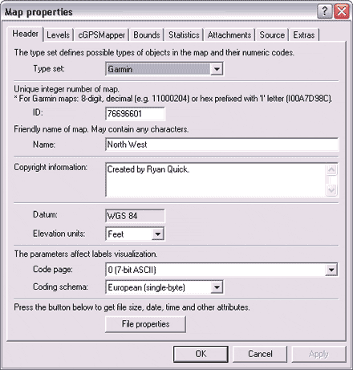

The ID has to be a number that no other map file that you'll be using in conjunction with this one has. The name field is what shows up when you add a map to be uploaded in Mapsource, and also will be displayed on your GPS.

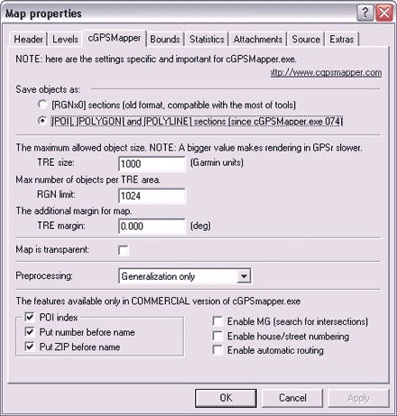

Set "RGN limit" to 1024. For "TRE size", a higher number (in the neighborhood of 5000) will give you a smaller file size but will make the map perform more slowly on your GPS. A lower number (500-1000) will make a bigger file but it'll be much faster on your GPS. 1000 was a good number for my map. If yours is smaller or less detailed, you can increase it.

Since we're making a trails only map here with no road or water elements, you'll probably want to click the "Map is transparent" box. This will allow your trails to be drawn on top of other Garmin maps that are loaded on your GPS.

For Preprocessing, "Generalization Only" is fine if you don't have routing information, and we don't.

Click OK and save your map.

**9)** **If your map is transparent,** close it in MapEdit, and then open the file in Notepad. Right above where your levels are listed, add this line:

DrawPriority=1

This will tell your GPS to display your map on top of the other maps you have loaded (ie Topo, City Select etc.).

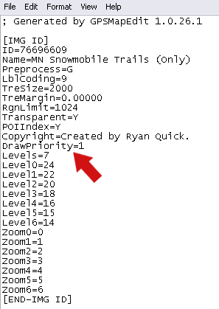

Save the file and open it back up in MapEdit.

**10)** Do "File > Export > Garmin IMG / cGPSMapper.exe". Select where you want to save your .img, and then click on "Run". cGPSMapper will do its thing, which could take anywhere from a few seconds to a few hours depending on the speed of your computer and size and complexity of your map.

**11)** You now have a Garmin GPS compatible .img file! To quickly upload it to your GPS, use SendMap.exe. Click [**here**](http://www.gpssledmaps.com/guide/upload.php) for instructions. You can also make a very cool automatic installer which will load your map into Mapsource. Instructions for that are [**here**](http://www.gpssledmaps.com/guide/make_installer.php).

**12)** Enjoy! If you think your map will be useful for other people, please send me an [**e-mail**](mailto:tracks@gpssledmaps.com) and I'll make it available on this site.

7/28/2008: The new version of Garmin MapSource (6.14.1) requires different Registry entries for your custom maps. You will get an error to reinstall MapSource and your maps... Note: you do not have to reinstall either.

You must use a Product Code = 1 and FID = in your test_pv.txt file when creating the Mappreview files

Registry entries are now made under the "Families\1" key instead of under "Products".   
See the corrected details in step #8 below.

Here's the steps:  
1. [Download digital elevation data](http://home.roadrunner.com/~creek/garmin.htm#1) from the USGS.  
2. [Convert elevation data to contours](http://home.roadrunner.com/~creek/garmin.htm#2).  
3. [Edit map](http://home.roadrunner.com/~creek/garmin.htm#3) layers and zoom levels.  
4. [Add stream and lake data](http://home.roadrunner.com/~creek/garmin.htm#4).  
5. [Add trails, roads, boundaries etc.](http://home.roadrunner.com/~creek/garmin.htm#9)  
6. [Add your own Tracks and Waypoints](http://home.roadrunner.com/~creek/garmin.htm#8).  
7. [Convert](http://home.roadrunner.com/~creek/garmin.htm#5) your map to a Garmin compatible map.  
8. [Create a preview](http://home.roadrunner.com/~creek/garmin.htm#6) image for MapSource.  
9. [Upload](http://home.roadrunner.com/~creek/garmin.htm#7) to your GPSr (using MapSource, SendMap, or a [memory card)](http://home.roadrunner.com/~creek/garmin.htm#10).  
  
Happy mapping,  
jacksan

Download and install the following free software:

 DEM2TOPO from: <http://people.uleth.ca/~brad.gom/dem2topo/index.htm>.  
... which requires ...  
 IDL Virtual Machine (IDL VM) from: [http://www.rsinc.com](http://www.ittvis.com/download/download.asp).  
(You have to download and install the full demo version just to get the "VM".)

 GPSMapEdit from [www.geopainting.com](http://www.geopainting.com/en/).

 cGPSMapper from [www.cgpsmapper.com](http://www.cgpsmapper.com/buy.htm#free).

Others Optional Software:  
 [SDTS2MP](http://www.robomatt.com/maps/makemaps_sdts2mp.html) lets you convert SDTS (the newer USGS format files from geocomm.com) directly to a .mp file.

 [MapSetToolKit](http://cypherman1.googlepages.com/home) takes care of the items in Step #8 above: Creates a preview map and loads your map into MapSource.

 SendMap from [www.cgpsmapper.com](http://www.cgpsmapper.com/buy.htm#free). Just unzip, nothing to install. Use this if you don't want to use MapSource to upload your maps to the GPS.

 Paper maps: If you have no other option and have a paper map that you 'must' get into your GPS then [this method](http://www.gpsinformation.org/adamnewham/article1/gpsmapper.htm) may be the only option.

 NSIS custom map installer. Create an .exe file that copies your map files and updates the registry automatically. Great for distributing custom maps. Definitely not for beginners.

 [MapWindow GIS](http://www.mapwindow.org/) is a free GIS program for working directly with digital map data!   
View and edit shapefiles, convert data, open a POI text file (from the link below) and   
convert it to a point shapefile...

 [BASINS 4](http://www.epa.gov/waterscience/basins/) from the EPA. Another free GIS package geared towards water data.

Favorite Data Sources:

 [MapCenter](http://mapcenter.cgpsmapper.com) - Perhaps someone has made 'your' map already.  
 [Ibycus](http://www.ibycus.com/ibycustopo/) - Dale has custom software and is cranking out topo maps of Canada and the US!!

 [seamless.usgs.gov](http://seamless.usgs.gov) - USGS Elevation data for making contours (this site goes down often, just try again later). Now also has now some global data.

 [nhd.usgs.gov](http://nhdgeo.usgs.gov/viewer.htm) - Awesome water feature data from the USGS!

 [OpenStreet](http://wiki.openstreetmap.org/index.php/Main_Page) has the latest and greatest road data. Us the mkgmap program to convert this data directly to a Garmin img file (skipping the cGPSMapper step).

 [data.geocomm.com](http://data.geocomm.com/) - Good source for roads, boundaries, and many others.

 I've seen many lists of free downloadable map data but [this one](http://libinfo.uark.edu/GIS/us.asp) is impressive.

 [POI](http://geonames.usgs.gov/pls/gnispublic/) (Points Of Interest) coordinates from the USGS. Download by [state](http://geonames.usgs.gov/domestic/download_data.htm) and import them into your map.

 [National Map Viewer](http://nmviewogc.cr.usgs.gov/viewer.htm) - USGS has made a one-stop shop for elevation, water, road data and much more. It points to the same data server as Seamless and NHD.

 [Geodata.gov](http://gos2.geodata.gov/): Another one-stop shop for all data types.  
 A bunch of [downloadable posters](http://www.ngdc.noaa.gov/mgg/image/globalimages.html) are available... way cool!

 [National Atlas](http://nationalatlas.gov/atlasftp.html) - Download the various shapefiles used in the National Atlas project.

 "[ENC direct to GIS](http://ocs-spatial.ncd.noaa.gov/encdirect/viewer.htm)" - NOAA nautical chart data.

 <http://www.geobase.ca/geobase/en/index.html> - Canadian data

 [National Park service](http://science.nature.nps.gov/nrdata/index.cfm) - some trail data (note that trail data is very hard to find). If you have a paper map you can try contacting the maker and ask for their trail shapefiles.

 [geocommunicator.gov](http://www.geocommunicator.gov/LSIS6/map.jsp) - Federal lands survey data (BLM).

 Get [coordinates](http://www.year2032.com/maps/testgeocoder.htm) of any place. Based on Google Map.

 See below: "Notes on where to get Stream/River/Lake and other DLG data".

Let's make some map...

You may want to start with something simple. There are a lot of steps, follow each step carefully until you get a feel for the process. While this tutorial is not thorough, it will let you produce very useful maps.

In this tutorial I create one map and add each of the components to it (contours, water, trails, roads). In reality I usually put contours on one map, water on another, roads on another, etc., and then combine all of them in MapEdit when I want to do the final compile. This makes it much easier to tweak various components without starting completely over each time.

1) Download high resolution DEM (Digital Elevation Model) data from the USGS at [seamless.usgs.gov](http://seamless.usgs.gov) ... or from the National Map.

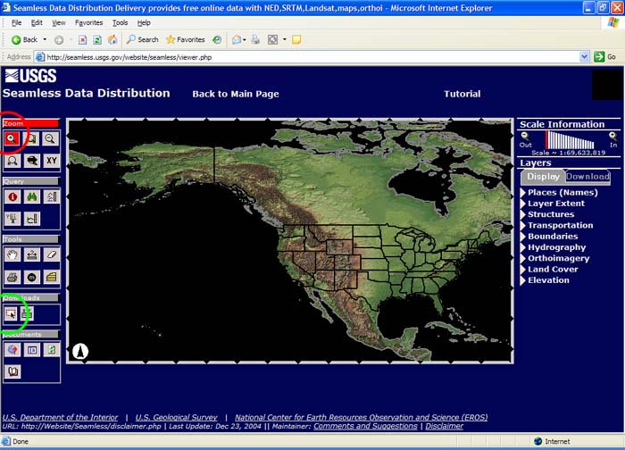

Use the graphical map interface to zoom in to the region of interest.

Click the "download area" icon, then draw a box (green) around your area of interest. The download window will come up automatically when you draw the box. If you are using the National Map you have to scroll down the toolbar on the left to find the Download button.

When the SDDS Request Summary page appears click "Change the download details".

Unselect the default "NED 1-arc second" option, (wait for the screen to completely update between each mouse click).

Select "NED, .3 arc second".

Pick GeoTiff format.

Download, save and then unzip the file.   
Make note of the file name and where you saved the data!

Note: This "NED .3 arc second" elevation data is extremely good. It has 10m resolution versus 30m for all the other DEM data sources (i.e. 24K topos)!

2) Convert the raw GeoTiff elevation data to contours using DEM2TOPO:

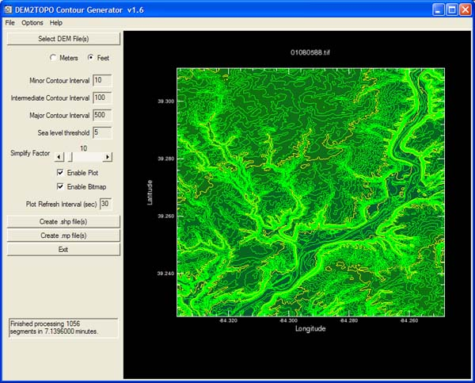

Note: DEM2TOPO versions after v1.9 produce much larger maps with smoother contours compared to the previous versions, the resulting file size is now 2-3x larger. This is because the Simplification Factor (SF) behavior has changed to not allow smaller, cruder maps anymore. In fact, changing the SF now has very little affect on the contour "quality". If you need to produce a smaller file size map with more crude (jagged) contours then use v1.9 or older. If you use an older version, setting the SF to 3 will produce a fairly small map while maintaining pretty smooth contours. It is a good compromise, I recommend it for very large maps.

|  |  |  |  |
| --- | --- | --- | --- |
| DEM2TOPO Version | SF | File Size | Contour Quality |
| v 2.6 | 100 | 6.1 mb | very good |
| v 2.6 | 10 | 6.3 mb | very good |
| v1.9 | 3 | 4 mb | good |
| v.19 | 10 | 3 mb | ok |

Creating Contours:

Double-click dem2topo.sav to start the program, the IDL VM application will automatically start.

Select units (feet or meters) and set your desired contour levels (i.e. 20', 100', 500'). Setting too small of a contour interval (i.e. 5') for a hilly region will result in a very cluttered map.

If you are working with a large map then disable the Plot and Bitmap. Otherwise too much time is wasted refreshing the screen.

Click Select DEM files then browse for your GeoTiff (TIF) data file. The screen will go blank for a while as the file is loaded and initialized...be patient.

Click Create .mp File. Your PC will run very slow while DEM2TOPO is chugging along! Very large maps (70mb data files) can take a couple hours to process.

3) Edit your new .mp map file in GPSMapEdit:

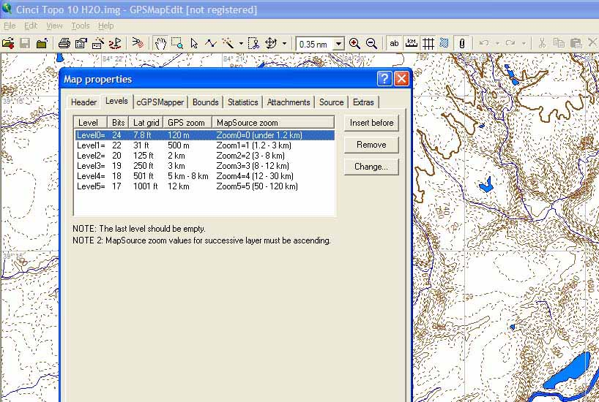

Open the newly created .mp file in GPSMapEdit

Change the displayed units to "Feet" if needed: Tools, Option, Units, Elevation/Depth.

Next click File, Map Properties...

Click on the cGPSMapper tab: select "Map is transparent". While working with a map I've seen this option uncheck itself so double check this setting before your final save. Note: Only make your map transparent IF you have another map(s) that you want to see at the same time. For instance you may or may not want to see the underlying basemap or City Navigator at the same time as the topo.

Click on the Header tab: enter a unique map ID number (8 digits).

Give the map a name, this is the name that will display in MapSource and on your GPS.

Click on the Levels tab: you have to edit the GPS "zoom levels" so the contours and streams appear at appropriate "zoom levels" on your GPS:

A Note about GPS Zoom and Data Visibility. As you zoom in on your GPS you see more data. Example: As you zoom in, a layer configured as "21 Bits" becomes visible at .5 miles (".5 mi" is displayed in the lower left corner of your GPS screen).  
24 bits becomes visible at 500 feet  
22 bits becomes visible at .3 miles  
21 bits becomes visible at .5 miles  
20 bits becomes visible at 1.2 miles  
19 bits becomes visible at 3 miles

Setting up Zoom Levels:  
Create all the Zoom levels (layers) before importing streams and other data: Edit, Map Properties, Levels. If you just finished using DEM2TOPO then your new custom map will already have 4 layers (0, 1, 2, 3) in it by default. Highlight the bottom layer on the list and click "Insert Before" to insert new layers. A total of five or six layers should be enough:

Layer 0 set for 24 bits - contains "minor" contours, Streams/Rivers/Lakes, and Waypoints.

Layer 1 set for 22 bits - contains "intermediate" contours, Streams/Rivers/Lakes and Waypoints

Layer 2 set for 20 bits - contains "major" contours and large Rivers

Layer 3 set for 19 bits - also contains large Rivers and large roads

Layer 4 set for 18 bits - this layer should ONLY have one small line (polyline) on it: click View, Levels, Level 4. Then select Tools, Create Object, and draw a tiny line anywhere (right-click and select "End" to finish drawing the line. Do not enter a name, press ESC). The purpose of this layer is to HIDE your custom map when you zoom way out on the GPS.

Layer 5 set for 17 bits - This layer must be totally empty.

IMPORTANT: Even though the "MapSource Zoom" field is not used for our purposes you must set it so that it increases as you go down the zoom list (see the screen shot above). Otherwise the map will fail to compile in cGPSmapper and you will get an error!

Add streams, rivers, and lakes by importing hydrography Shapefiles from NHD: File, Import, ESRI Shape.   
See the "[Adding Streams](http://home.roadrunner.com/~creek/garmin.htm#4)" section below for the steps to import Stream data.

Add your own Tracks and Waypoints that you have saved in your GPS. See the "[Adding Tracks and Waypoints](http://home.roadrunner.com/~creek/garmin.htm#8)" section below.

Add any other object you wish: Trails, Roads (see section below), boundaries, parks.

Remove any duplicate objects. Select the Tools menu then select "Remove Object Duplicates".

Delete any extra items that are outside your topo area (there will be many streams and lakes). Click the arrow icon on the toolbar then "window" the items you want to delete, then press the Delete key. To do this: Zoom out to see your full map (View, Full Map). Delete the large areas that appear to be empty that surround your area of interest. Do this even if you don't see anything there. There will be many tiny streams and lakes that are not visible unless you are zoomed way in.   
  
NOTE: Don't accidentally delete an entire river because some if it extends out of your contour area. You can use the TRIM command to remove parts of a river that run outside your area of interest. Click the Trim button, draw a rectangle around your area, right-click in the rectangle and select "Trim Outside".

Double-check the "Map is Transparent" option.

Save your map in Polish format (.mp).

4) Convert the new .mp file to a Garmin compatible .img map using cGPSMapper:

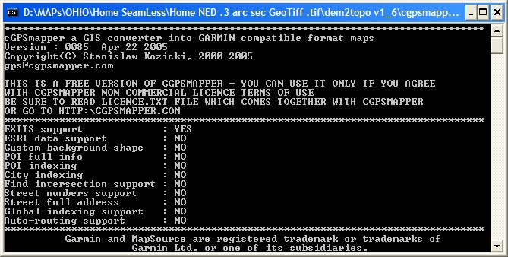

Copy cgpsmapper.exe to the same folder as your map (.mp) file.

Drag and drop your .mp file onto the cgpsmapper.exe file.

It will automatically execute in a DOS window and create an .img file.

OR...

From within GPSMapEdit select File, Export, Garmin IMG. cGPSMapper will fire up and run automatically.   
Be patient, it will appear to hang for several minutes as the data is first read in and processed.

If you get an error (Error E021, code 40...) you probably don't have your layers set up correctly. See the "Important" note in step 7 above.

5) Create a Preview Map and Upload to your GPSr using MapSource :  
Upload you custom map together with Garmin maps (like City Select) using Garmin MapSource.  
See below for how to use the "USB Mode" to simply copy your map to the memory card of the new GPSMap Cx units.

[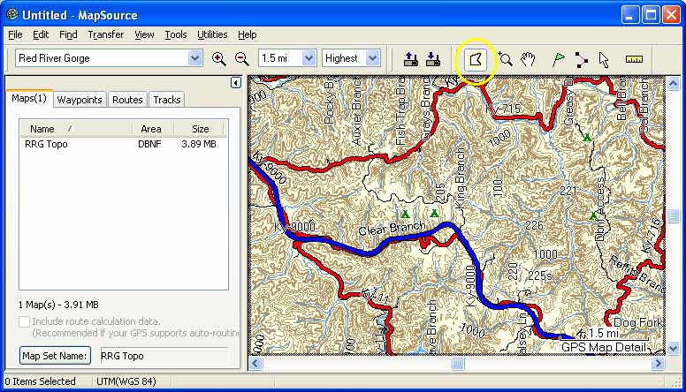](http://home.roadrunner.com/~creek/RRGTopo.htm)  
One of my bigger maps as seen in MapSource.  
(click for details)

Whenever you upload a map using MapSource it will erase all existing maps on the GPS.   
You have to upload all maps at the same time.

For MapSource to be able to see your new map you must create a "preview map":  
 You can use [MapSetToolKit](http://cypherman1.googlepages.com/home) instead of the steps listed below.

First, you must give your map a name of all numbers: 10000123.img. This should be the ID Number you assigned in GPSMapEdit (File, Map Properties).

Create a folder named "custom" under the Garmin folder and copy your custom map(s) to it.

Copy cgpsmapper.exe to the same folder.

Copy test_pv.txt (found in the Test_Map folder of cGPSmapper) to your custom folder.

Use Notepad to edit test_pv.txt so it looks something like this:

[Map]  
FileName=CINtopo ' this will be the output file name for the map .img and .tdb files  
MapVersion=100   
Color=32  
  
[_id]  
ProductCode=1 ' MUST be 1 (as of MapSource version 6.14.1)  
FID= 730 ' Use your own "Family Id" that is not already in use. Note: Decimal 730 is   
[End] equivalent to hex 02,DA and to "inverse hex" of DA,02.   
Use the "inverse hex" in the registry entry below.

Levels=4 ' Number of Levels detailed below...  
Level0=24 ' List the layers of your map (you do not need to list them all)  
Level1=22   
Level2=20   
Level3=17 ' anything lower than the lowest in your map  
  
Zoom0=5 ' not really sure.?  
Zoom1=6  
  
MapsourceName=CINtopo ' This will be the name of the files and registry entry that are created.  
MapSetName=CinTopo 'anything  
CDSetName=CinTopo 'This is the name that shows up on the Map Setup page on your GPs.   
Copy1=Garmin  
Copy2=Stan  
[End-Map]

' erase the Dictionary section, it is not needed.

[Files]  
img=10000123.img 'This is your map file name. *** IT MUST BE ALL NUMBERS ***   
[END-Files]

' YOU CAN INCLUDE SEVERAL OF THESE "img" LINES. They will all be compiled into a single preview map, and you can select and upload them individually to your GPS using MapSource.  
You can add more maps (IMG lines) to this section later, then create a new preview file, and you're done.

If the img= name does not match your map name and if it is not all numbers then you will get a "Layer 0 cannot be empty" error.

Then, open a "command window" (DOS prompt): In Windows click Start, Run , then type "cmd".

Change directory to the "custom" folder: Type "cd c:\garmin\custom" in the command window.

Create the preview files: type "cgpsmapper pv test_pv.txt".   
This creates a small preview map file (.img), a table file (.TDB) and a registry file (.reg).

Edit the registry file that you just created (i.e. CINtopo.reg): Right click on it and select Edit.   
Change the folder names so they point to your custom folder. Yes, you need the double back-slashes.

REGEDIT4  
[HKEY_LOCAL_MACHINE\SOFTWARE\Garmin\MapSource\Products\CINtopo]  
"LOC"="C:\\Garmin\\custom\\"  
"BMAP"="C:\\Garmin\\custom\\CINtopo.img"  
"TDB"="C:\\Garmin\\custom\\CINtopo.tdb"

MapSource 6.14.1 now requires registry entries under "Families\name\1" instead of "Products\name":

REGEDIT4  
[HKEY_LOCAL_MACHINE\SOFTWARE\Garmin\MapSource\Families\CINtopo]  
"ID" = hex: DA,02 (this is the "inverse hex" of the FID=730 in the .txt fie above)  
  
[HKEY_LOCAL_MACHINE\SOFTWARE\Garmin\MapSource\Families\CINtopo\1]  
"LOC"="C:\\Garmin\\custom\\"  
"BMAP"="C:\\Garmin\\custom\\CINtopo.img"  
"TDB"="C:\\Garmin\\custom\\CINtopo.tdb"

According to [MrZumma](http://forums.groundspeak.com/GC/index.php?showtopic=180243) use the following for 64-Bit Vista:

REGEDIT4  
[HKEY_LOCAL_MACHINE\SOFTWARE\Wow6432Node\Garmin\MapSource\Families\SE_MN]  
"ID"=hex:64,00  
  
[HKEY_LOCAL_MACHINE\SOFTWARE\Wow6432Node\Garmin\MapSource\Families\SE_MN\1]  
"Loc"="C:\\Garmin\\Custom\\"  
"Bmap"="C:\\Garmin\\Custom\\SE_MN.img"  
"Tdb"="C:\\Garmin\\Custom\\SE_MN.tdb"

Click File, Save to save your changes.

To "run" the registry file just double click it, select "yes" to load it into your registry.

Start Mapsource. If you made a registry file mistake you will get an error saying to reinstall MapSource. Don't worry, you don't have to reinstall. Just run regedit (seek help if unsure about this!) and remove the "HKEY_LOCAL_MACHINE\SOFTWARE\Garmin\MapSource\Products\CINtopo" or "... Families\Cintopo\1" keys as detailed in your .reg file. Repeat the above steps until you get it right.

You should now see your map listed in MapSource along with your other Garmin maps in the 'Product' list.

Select (click) your map and the preview map will show up as a blank rectangle in the map area of the screen. You can zoom in to see more detail of your custom map.

You should now be able to use the 'Map Tool' icon to select your custom map for uploading and upload it with your other Garmin and custom maps, and waypoints etc..

OFTEN, the .TDB file is not created correctly. Open it in a hex editor and bits 5 and 6 (count the bits starting at "0") should be your "ID" as shown in your .reg file (i.e.: 64, 00). Enter it and Save.

How to copy your map to the memory card of the new GPSMap Cx units using "USB Mode".

Note: To upload multiple maps use Mapsource, it will combine them into a single gmapsupp.img file. Then you can use this USB mode to back it up, rename it, create new ones, and swap them around.

FIRST...BACKUP THE ORIGINAL MAP FILES ON YOUR CARD !!!

Generate the .img map as usual. Change the name of the .img file name to gmapsupp.img.

Turn on unit.

Attach the 60Cx via the USB cable to your computer.

After the device has been recognized, go to:  
-->Main Menu--> Interface--->USB Mass Storage

The system enters a USB storage mode and the GPS will appear as a disk drive in Windows.

Enter the disk drive, go to the folder called Garmin. Create the folder if it does not exist.

You DID back up ALL the original map files (i.e. gmapsupp.img, etc) from your GPS first, right? Ok, then copy the gmapsupp.img file to the Garmin folder.

Disconnect unit.

Adding STREAMS to your custom map

You can add Streams, Rivers, and Lakes and other "line" features (roads, trails, railroads etc.) to your topo map.

⇒ Excellent water (hydrography) data can be downloaded from [nhd.usgs.gov](http://nhdgeo.usgs.gov/viewer.htm). The advantages of this site is that the data is high resolution, it is already in shapefile format, and it contains the stream names! It is much more detailed than the SDTS data from GeoComm and much better than the water data from Seamless. The user interface at NHD looks similar to Seamless but the commands are different.

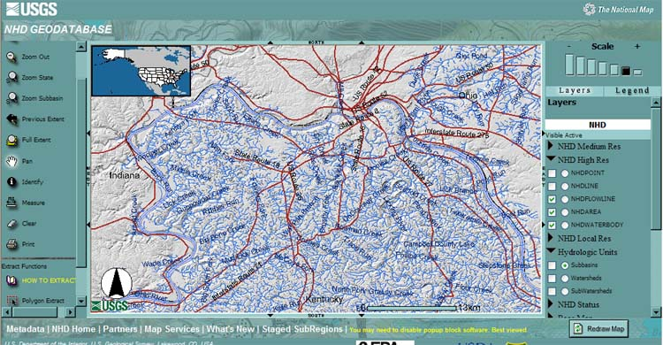

Note: Water data for an entire "subbasin" watershed (often a very large area) is downloaded together at one time.

Zoom in to your area of interest.

Under NHD High Resolution on the right side of the screen select and place a check mark on NHDFlowline, NHDArea, and NHDWaterBody.

If these don't show up you may have to zoom in more on the map.

In the Hydrologic Units tab place a 'dot' in the "Subbasins" circle.

Click the "Redraw Map" button (bottom right corner) to display the things you just turned on.

You will see various areas outlined, these are the Subbasin watersheds that are downloaded as one chunk.

Click the "Polygon Extract" icon on the left.

Then click once on the map anywhere within the Subbasin that you want to download.

When the next screen appears select High Resolution and Shapefile as the data format, then provide your email address.

In 10 minutes to an hour or even up to a day later you will receive a "data ready" email that contains a link to where you can download your data file. Click the link, download and unzip the data. Make note of where you save the "water" data.

The shape files that we need will be in the Hydrography sub-folder:  
"Flowline" is small streams.  
"Waterbody" is lakes.  
"Area" is large rivers.

Next, import these shapefiles into your topo map using GPSMapEdit: File, Import, ESRI Shape:

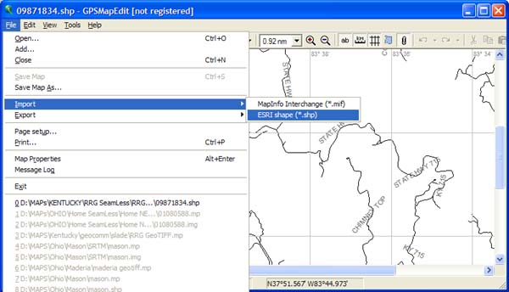  
  
1) When prompted, select the "Type of data" that you are importing: Stream=0x0018, Small Lake=0x0040, Major River=0x0046, etc...  
  
2) On the next screen: If and only if you see the actual names of the items you are importing (actual stream, lake, river, road, or railroad names) then highlight the column that lists their names. Otherwise uncheck the "Select field for labels" checkbox.  
  
3) On the next screen, select the correct Coordinate System for your data (such as Latitude/Longitude deg). Pick the Zone # if your data is "UTS" data. Then, select the correct Datum (often WGS84).  
  
4) On the next screen select "Zoom levels to import". This is where you pick the layers that you want to put your streams, etc on. Import streams (Flowlines) and lakes (Waterbodies) to Layers 0, 1 (and 2 if you want to see streams more often on your GPS). Import rivers (Areas) to Layers 0, 1, 2, and 3 since you'll want the large rivers to show up 'more' (i.e. at a lower zoom).

Other Data you can also import into your map:

DLG DATA: Streams, lakes, roads, railroads, boundaries etc. data is called "Digital Line Graph" (DLG) data. Each 'type' of data comes in its own file and often has to be downloaded separately: such as Transportation (roads, trails), Hydrography (water), Boundaries, Hypsography (contours, low quality compared to the custom contours we just made), Public lands, etc. Note that DLG data comes in various file formats that each require different handling by you:

The common DLG file formats are "Shapefiles", "DLG-O", and "SDTS":

⇒ Shapefiles has a .shp file extension: This is a simple and preferred format that contains line data and feature names. It is typically in a Lat/Long coordinate system and WGS84 Datum.

⇒ DLG-O (O is for "Optional") has a .dlg file extension: This is the older traditional USGS format. It contains all the data you see on typical 24K topo maps. It is usually in the UTM coordinate system (NAD27 Datum) with a specific Zone# of 1-60. Make note of the Zone number when you get the data!!!.

Using DLG-O data:   
These must first be converted to Shapefiles before we can use them. Open a DLG-O file in a program like Global Mapper and export it as a shapefile: File, Export Vector data, Shapefile. Unfortunately, all the data will be converted to a single data type and you will loose all the object names. Then, Import the shapefiles into GPSMapEdit as described above.

⇒ SDTS has a TAR.GZ file extension and unzips ("un-tars" to be correct) to several files, each with a .ddf file extension. This is the same data as in DLG-O files but is in the new USGS format. It is usually in the UTM coordinate system (NAD27 Datum) with a specific Zone# of 1-60. Make note of the Zone number when you get the data!!!.

Using SDTS data:

If it is a standard 24K or 100K SDTS file you can convert it directly to a .mp file using the [SDTS2MP](http://www.robomatt.com/maps/makemaps_sdts2mp.html) program! This works very good. (Thanks RoboMatt for adding the 100K map support)

Otherwise, these would have to be converted into Shapefiles first them imported into your map. Follow the instructions above for DLG-O to convert a SDTS to a shapefile using Global Mapper.

Some other sources for downloading DLG data:

 The DLG shapefile data from "Seamless" ([seamless.usgs.gov](http://home.roadrunner.com/~creek/seamless.usgs.gov)) is not very good. The water data is from NHD but is not very good... it must be based on the lower resolution NHD data. The Seamless "BTS" road data, and the "Atlas" data seem to be based on 1:200K maps so it is not very detailed, or accurate. However, the BTS road data is the only road data I could find that contains the road names. I believe this is the same data as the "Census" road data available from other sources.

The Seamless DLG data is already in shapefile format so you won't need to convert it using Global Mapper. Your choice depends on whether you need accuracy (use the SDTS data described below), or you want road names (use Seamless BTS data). I much prefer Garmin City Select™ over making my own road maps. :{>  
  
 The SDTS format of DLG data at GeoComm ([data.geocomm.com)](http://data.geocomm.com/) is the same data that the USGS puts in typical "24K Topo" maps. It is pretty accurate although somewhat dated. Their "100K" DLG data is just as accurate and detailed as the 24K data, it simply covers a larger area. If you download a standard 24K or 100K SDTS file you can convert it directly to a .mp file using the [SDTS2MP](http://www.robomatt.com/maps/makemaps_sdts2mp.html) program. This works pretty good! (Thanks RoboMatt for adding the 100K support!)

Creating a ROAD map  
The latest road data sources (http://www.openstreetmap.org/) have data that is as good or better than Garmin and other map makers. OSM now includes the TIGER Sept 2007 database!

If you add roads to your Topo you may NOT want to make the Topo transparent, otherwise you would see City Select roads (if you also had CS loaded) at the same time as your Topo roads... can be pretty confusing and cluttered.

Creating a Road map:  
You will need to create an empty map and define your layers: 21 (roads), 18 (for a single line), 17(empty) in GPSMapEdit before you import the road Shapefiles. Remember, if the DLG data is a standard 24K or 100K SDTS file then you can convert it directly to a .mp 'map' using SDTS2MP and voila, a nice separate road map. If not, then the only way I know of to create an empty map is to open an existing map (.mp) then delete everything in it: highlight everything using the arrow icon then press delete. Be sure to do this for each and every layer of he map. Next, create the layers you want then import your road shapefiles as described above in the Streams section..

For those who like pain, I hear there are some very complex techniques, not discussed here, for creating very accurate, up-to-date, routable road maps.

Adding TRACKS and WAYPOINTS to your custom map

You can download Tracks and Waypoints from your GPS  
and add them to your custom map as a trail or POI.

Download the Tracks and Waypoints from your GPS using MapSource.

Save the Track as a .gpx file.

Save your Waypoints as a .gpb file. Only do a couple major ones otherwise your map will be very cluttered. Also, you cannot do a "Find" on Waypoints loaded at the map level.

Add a Track:  
IMPORTANT: When you create a Track on your GPS it is your "Active" Track, and when you save it on your GPs it becomes a "Saved" Track. ACTIVE Tracks have much more detail than SAVED ones. So, try to use only Active Tracks when creating maps.

Open you custom Topo map in MapEdit and add your .gpx file: File, Add, then browse to your Track file.

Click the Edit menu then click Select and All Tracks.

Right click one of your tracks and select Convert To, then select Polyline.

Check the Level 0, 1 and 2 boxes then click Ok.

Select #16 Walkway/Trail as the Type and click Ok. You can select a different "Type" to have the trail show up as a color and linetype that is easier to see on your particular GPS.

Change the view to Level 4 (or the highest level you have in the map). This will let you see the original unconverted Tracks: View, Levels, Level4

Right click on a Track and select Detach File. It will disappear. All the original unconverted Tracks will disappear (provided they were all still "selected").

View your entire map: View, Levels, Level0

Add Waypoints: (same process as Tracks)

Open you custom Topo map in MapEdit and add your .gpb file: File, Add then browse to your waypoint file.

Click the Edit menu then click Select and All Waypoints.

Right click on one of your Waypoints and select Convert to...Point.

Check the Level 0, 1 and 2 boxes then click Ok.

Select a "Type" and click Ok. Note that some Waypoints symbols may show up differently in MapEdit compared to on your GPS.

Change the view to Level 4 (or the highest level you have in your map). This will let you see the original unconverted Waypoints: View, Levels, Level4

Right click on a Waypoint and select Detach File. It will disappear. All the original unconverted Waypoints will disappear if they were all still "selected".

View your entire map: View, Levels, Level0

Save your map.

Using SendMap to upload maps to your GPSr:

Hint: If you are using a USB-to-Serial converter be sure to set it to a high baud rate (i.e. 115K).

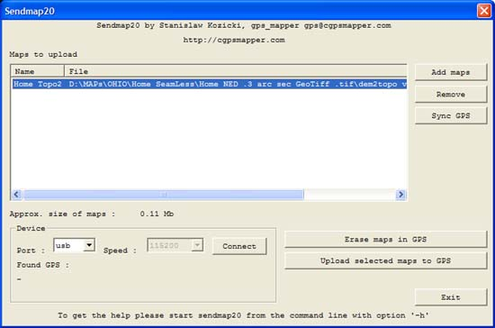

Run sendmap20.exe.

Select your map file(s) and click Upload. Exisitn maps (except Basemap) will be deleted so you must upload all desired maps at the same time.

OR ...

"Associate" .img files with sendmap20.exe: Right click on the .img file, select "Open with", then "Choose Program", browse to sendmap20.exe. Checkmark the "Always use the selected program..." box. Click OK.

Then, just double-click the .img and the upload will start automatically.

## REMOVING WATERMARKS FROM CGPSMAPPER

In case you dont get it to work (it works only in 80% of the cases) open the img file with an hex editor, Find the string GARMIN RNG after that string find the first byte 02 then take the first four bytes and replace them with 28 00 00 00  
  
e.g you find 02 8F 32 00 after the GARMIN RNG string then replace them with 28 00 00 00